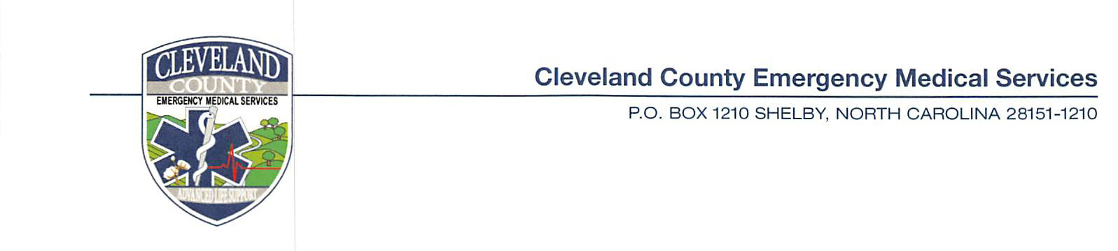
To: All Prospective Bidders

From: Melissa Parker, Captain
Cleveland County EMS

Date: July 27, 2020

Re: Bid for Medical Supplies

The attached bid sheet is for our medical supplies. We have tried to improve our process this year to include as many product numbers as possible.
This bid pricing will be good until February 15, 2021. At that time, we will verify that prices will remain the same or if a new bid sheet is necessary to ensure that prices are set until June 30, 2021.
The quantity of items is not absolute. It could be more or less but we expect to purchase the bulk of equipment immediately following the closing of the bid (once pricing is confirmed and compared). There will be NO SUBSTITUTIONS.
If you have any questions regarding items, please call 980-484-4603 and we will be happy to assist.
Bids are due August 12th, 2020 by 4:00 pm. Options for returning the bid documents via email to donna.murray@clevelandcountyems.com or mail to our PO Box or hand deliver to 1333 Fallston Rd. Shelby, NC 28150
Cleveland County EMS
Medical Bid
PO Bo 1210
Shelby, NC 28151

Bid results will be available once results are tallied and will be posted on the www.clevelandcounty.com website.

